# Trapezoidal distribution

Def

A distribution with graph that is trapezoid.

PDF

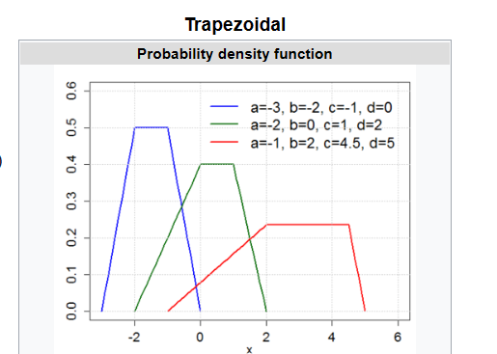



CDF

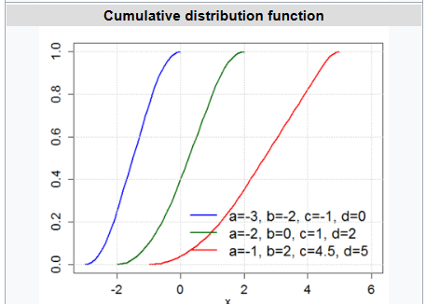

U,{db38c893-dfdf-4236-b8dd-95568dd21d3c}{58},3.125,3.125

Expected Value

正在插入影像...

Variance

正在插入影像...

Entropy

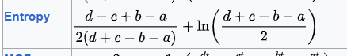

Ref

[Trapezoidal distribution - Wikipedia](https://en.wikipedia.org/wiki/Trapezoidal_distribution)